Software Engineering Group Project 09

Welsh Vocabulary Tutor Design Specification Standards

|  |  |
| --- | --- |
| Author: | Dixon[dkc2], Kassy[kab71] |
| Config Ref: | SE.QA.05 |
| Date: | 4th March 2020 |
| Version: | 1.0 |
| Status: |  |

Department of Computer Science

Aberystwyth University

Aberystwyth

Ceredigion

SY23 3DB

Copyright © Aberystwyth University 2019

CONTENTS

CONTENTS 2

1. Introduction 3

1.1 Purpose of this Document 3

1.2 Scope 3

1.3 Objectives 3

2. Decomposition Description 3

2.1 Programs in System

2.2 Significant Classes

2.3 Modules shared between programs

2.4 Mapping from requirements to classes

3. DEPENDENCY DESCRIPTION

3.1 Component Diagrams

4. INTERFACE DESCRIPTION

5. DETAILED DESIGN

5.1 Sequence diagrams

5.2 Significant algorithms

5.3 Significant data structure

REFERENCES 3

DOCUMENT HISTORY 4

# Introduction

## Purpose of this Document

The purpose of this documentation is to specify the design specification in the project. This version of the Design Specification standards is specific to CS22120 projects.

## Scope

This document specifies the necessary layout and content of a design specification.

This document contains a UML Diagram, a Sequence Diagram

## Objectives

The main objective is to aid the production of a design specification which is a complete and accurate translation of the client’s requirements into a description of the design elements necessary for the implementation phase. These will generally include the software structure, components, interfaces, and data. In a complete design specification, each requirement must be traceable to one or more design entities.

# decomposition description

**2.1 Programs in system**

*(write a brief sumary of programm we just have 1, maybe UI is separate)*

**2.2 Significant classes in each program**

2.2.1 -> Dictionary

2.2.2 -> App

2.2.3 -> Setting

2.2.4 -> Revise

*(write a few sentence to explain what there are and why there are significant classes)*

**2.3 Modules shared between programs N/A**

**2.4 Mapping from requirement to classes**

|  |  |
| --- | --- |
| *Requirement* | *Classes providing requirement* |
| FR1 | Dictionary, Word |
| FR2 | Comparator, Word, Dictionary, MyList |
| FR3 | Dictionary, Word |
| FR4 | MyList, Dictionary |
| FR5 |  |
| FR6 |  |
| FR7 |  |
| FR8 |  |
| FR9 |  |
| FR10 |  |

**3.DEPENDENCY DESCRIPTION**

**3.1 Component Diagrams**

**4. INTERFACE DESCRIPTION**

TBI - to be implemented

Classes and their relations

**5. Detailed Design**

**5.1 Sequence Diagrams**

A sequence diagram is an interaction diagram that shows the details on how operations are carried out. The purpose of sequence diagram is to model the interaction between objects within a collaboration that realizes an operation.

This is the sequence diagram:

(working on it)

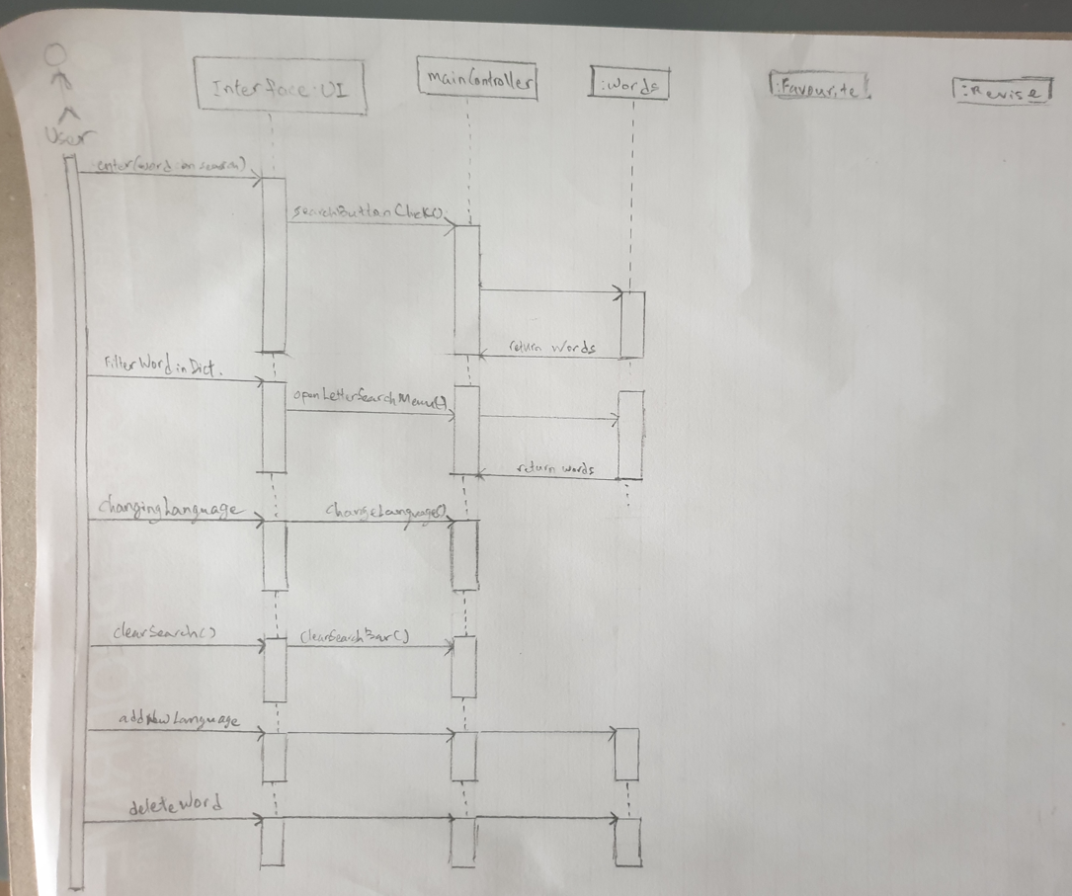

**5.2 Significant Algorithms**

- TreeMap -> Get the most star from myList for learning

-

**5.3 Significant Data Structure**

- Binary Tree ->Dictionary

- Array List -> revise

-List -> Revise

*(write where we using them)*

REFERENCES

[1] Software Engineering Group Projects: General Documentation Standards. C. J. Price, N. W. Hardy, B.P. Tiddeman. SE.QA.03. 1.8 Release

[2] Software Engineering Group Projects: General Documentation Standards. C. J. Price. SE.QA.02. 2.3 Release

[3] Software Engineering Group Projects: Design Specification Standards. C. J. Price. SE.QA.05. 2.1 Release

1. Software Engineering Group Project: Quality Assurance Plan. C. J. Price. SE.QA.01 2.2 Release
2. Software Engineering Group Project: Welsh Vocabulary Tutor User Interface Use Case Document. Taavi Karvanen. Mariuz Bialoszewski. SE.QA.UIUC. 1.0
3. Software Engineering Group Project: Producing the Final Report. C.J.Price. SE.QA.10 2.2 Release
4. Software Engineering Group Project: Operating Procedures and Configuration Management Standards. C.J.Price. Se.QA.08. 2.4. Release
5. Software Engineering Group Project: Java Coding Standards. C.J.Price. A.McManus. SE.QA.09. 2.0. Release
6. Software Engineering Group Project: Project Management Standards. C.J.Price. SE.QA.03. 2.3. Release

DOCUMENT HISTORY

| *Version* | *CCF No.* | *Date* | *Changes made to document* | *Changed by* |
| --- | --- | --- | --- | --- |
| 1.0 | N/A | 05.03.2020 | N/A - original version | Kab71 |